PART-A

**Title of Micro Project:** GYM management system

1. Brief Introduction:

Gym and club management systems provide fitness businesses the functionality to manage schedules, memberships, and facilities. The capabilities of gym management systems include storing member information in a database, managing financial records, scheduling classes, and reserving facilities.

1. Aim of the Micro Project: The aim of the micro-project is to understand and use the concepts of software

engineering to GYM management system

1. Action Plan

|  |  |  |  |  |
| --- | --- | --- | --- | --- |
| **Sr.**  **No.** | **Details of Activity** | **Planned Start Date** | **Planned Finish Date** | **Name of Responsible Team Members** |
| 1 | Selection of Topic | 06/04/2023 | 06/04/2023 | Harshit Chauhan  Jagannath Kumbhar  Muhammed shaikh |
| 2 | Implementation | 11/04/2023 | 12/04/2023 |
| 3 | Report generation | 21/04/2023 | 21/04/2023 |

**4.0 Resources Required**

|  |  |  |  |  |
| --- | --- | --- | --- | --- |
| **Sr.**  **No.** | **Name of Resource/Material** | **Specifications** | **Qty** | **Remarks** |
| 1 | Visual paradigm |  | 1 |  |
| 2 | Command prompt |  | 1 |  |
| 3 | Operating System | Windows 11 | 1 |  |
| 4 | Microsoft word |  | 1 |  |

**PART-B**

**Title of Micro Project:** GYM management system

Brief Description:

1. Gym and club management systems provide fitness businesses the functionality to manage schedules, memberships, and facilities. The capabilities of gym management systems include storing member information in a database, managing financial records, scheduling classes, and reserving facilities.
2. Aim of Micro Project: The aim of the micro-project is to understand and use the concepts of software engineering to GYM management system.
3. Actual Resources Used:

|  |  |  |  |  |
| --- | --- | --- | --- | --- |
| **Sr.**  **No.** | **Name of Resource/Material** | **Specifications** | **Qty** | **Remarks** |
| 1 | Visual Paradigm |  | 1 |  |
| 2 | Command prompt |  | 1 |  |
| 3 | Operating System | Windows 11 | 1 |  |
| 4 | Microsoft word |  | 1 |  |

**7.0 Output:**

**CLASS DIAGRAM**

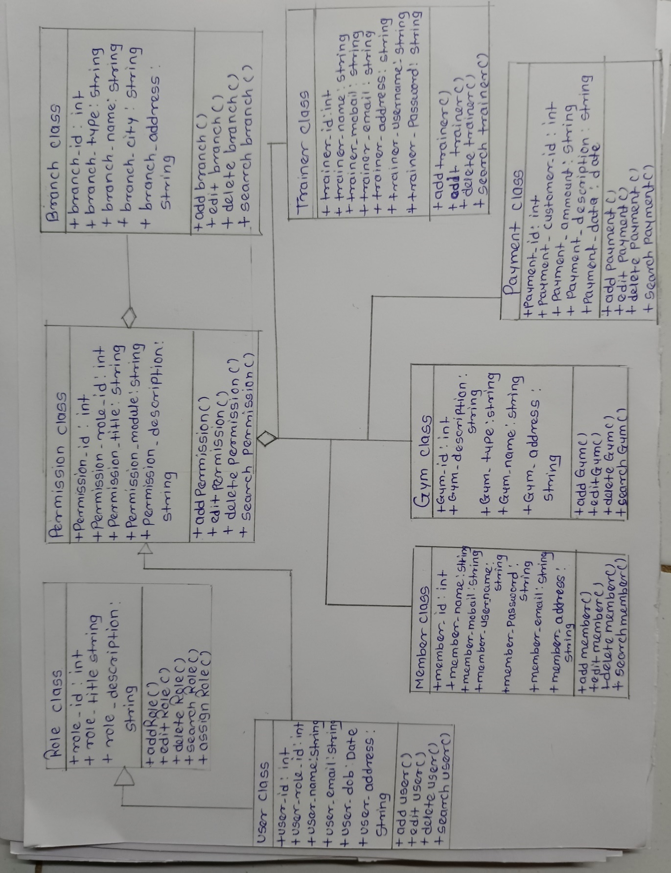

**USE CASE DIAGRAM**

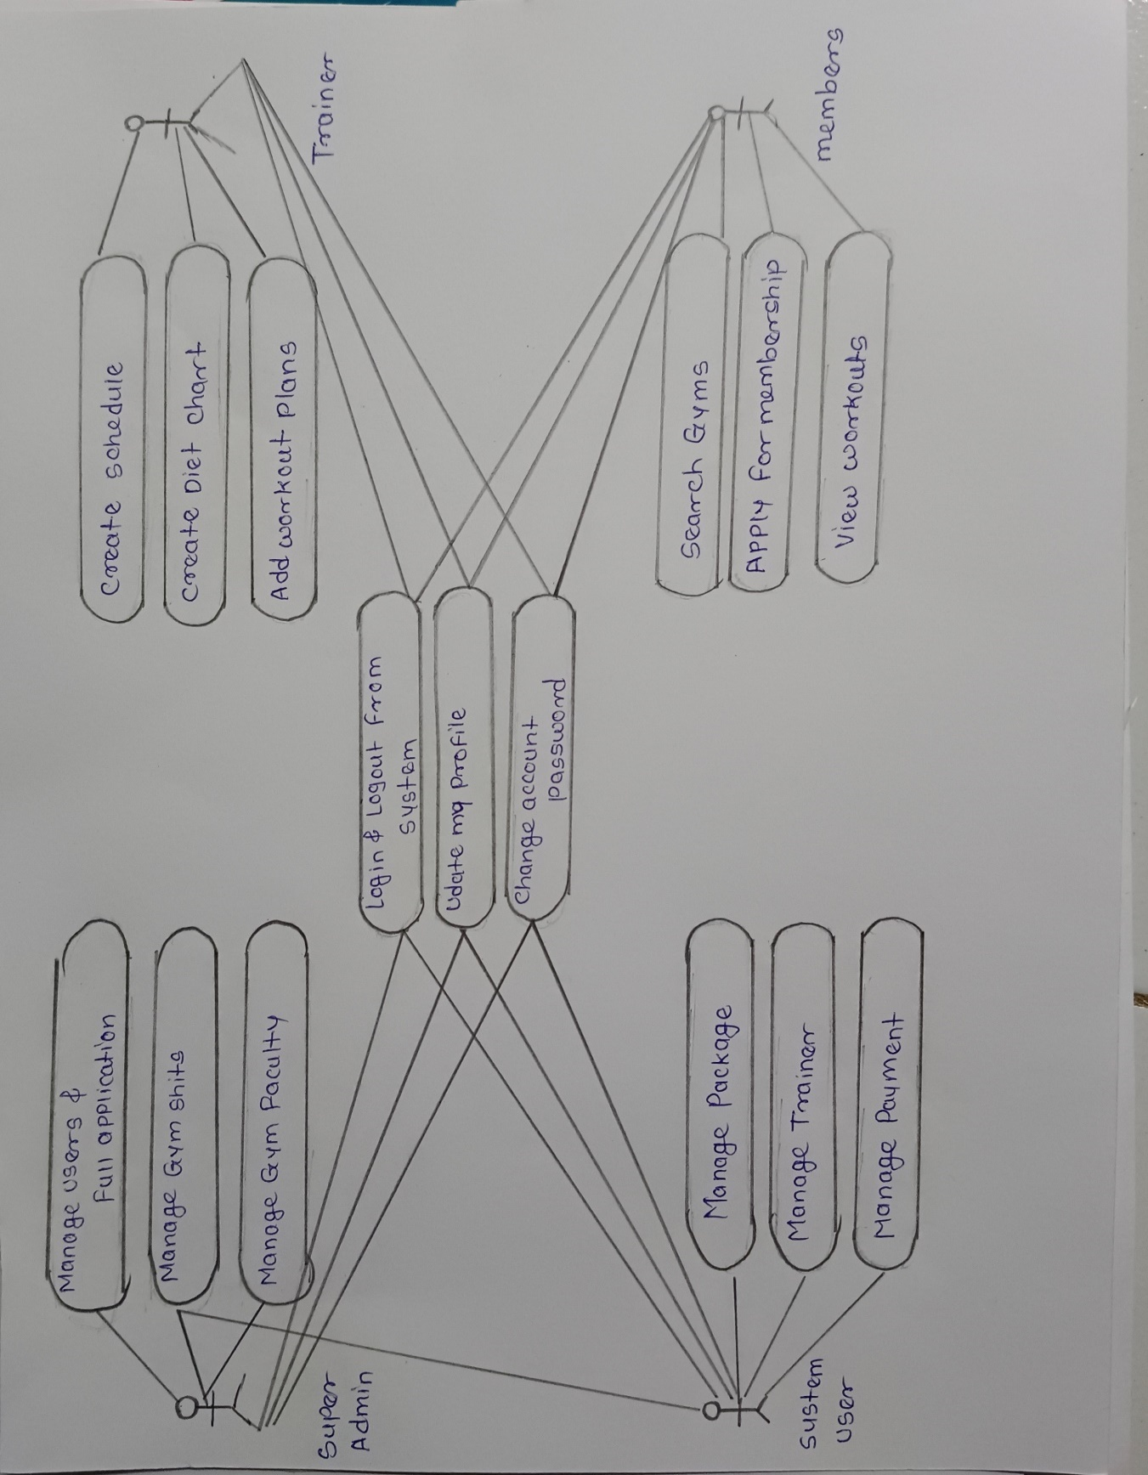

**ER DIAGRAM**

**DATA FLOW DIAGRAM**

**ACTIVITY DIAGRAM**

**SEQUENCE DIAGRAM**

**Name of Student:** Harshit Chauhan  **Roll No:**22202A1005

**Name of Programme:** Information Technology **Semester:** 4th

**Course Title:** Software Engineering **Code:** 22413

**Title of the Micro Project:** GYM management system

Course Outcomes Achieved: Prepare software requirement specification.

Micro Project Evaluation Sheet

|  |  |  |  |  |
| --- | --- | --- | --- | --- |
| **Process Assessment** | | **Product Assessment** | | **Total Marks 10** |
| **Part-A**  **Project Proposal**  **(Mark-2)** | **Project**  **Methodology**  **(Mark-2)** | **Part-B**  **Project Report/**  **Working Model**  **(Marks-2)** | **Individual**  **Presentation/**  **Viva**  **(Marks-4)** |
|  |  |  |  |  |

**Note: Every course teacher is expected to assign marks for group evolution in first 3 columns and individual in 4th columns for each group of students as per rubrics.**

**Comments/Suggestions about teamwork/leadership/inter-personal communication (if any)**

**----------------------------------------------------------------------------------------------------------------------------**

**----------------------------------------------------------------------------------------------------------------------------**

**Any other Comments:**

**----------------------------------------------------------------------------------------------------------------------------**

**----------------------------------------------------------------------------------------------------------------------------**